Password Strength Checker
Project Report

Student Details
- Name: Kritika Grover
- Course: Bachelor of Computer Applications (BCA)
- Project Title: Password Strength Checker
- Technology: Python, Visual Studio Code

Abstract
This project evaluates the strength of a password using Python. It checks password length, uppercase letters, lowercase letters, digits, and special characters, then classifies the password as Weak, Medium, or Strong while suggesting improvements.

Aim
To develop a Password Strength Checker that evaluates password strength using predefined security rules.

Objectives
• Validate password length
• Check uppercase, lowercase, numbers and special characters
• Display password score
• Suggest improvements for weak passwords

Tools Used
Python 3
Visual Studio Code
Windows OS

Concepts Used
Variables, User Input, Conditional Statements, Regular Expressions (re), String Handling

Algorithm
1. Start
2. Input password
3. Check length
4. Check uppercase
5. Check lowercase
6. Check digit
7. Check special character
8. Calculate score
9. Display strength
10. End

Flowchart
Start
↓
Enter Password
↓
Check Length
↓
Check Uppercase
↓
Check Lowercase
↓
Check Number
↓
Check Special Character
↓
Calculate Score
↓
Display Strength
↓
End

Python Code
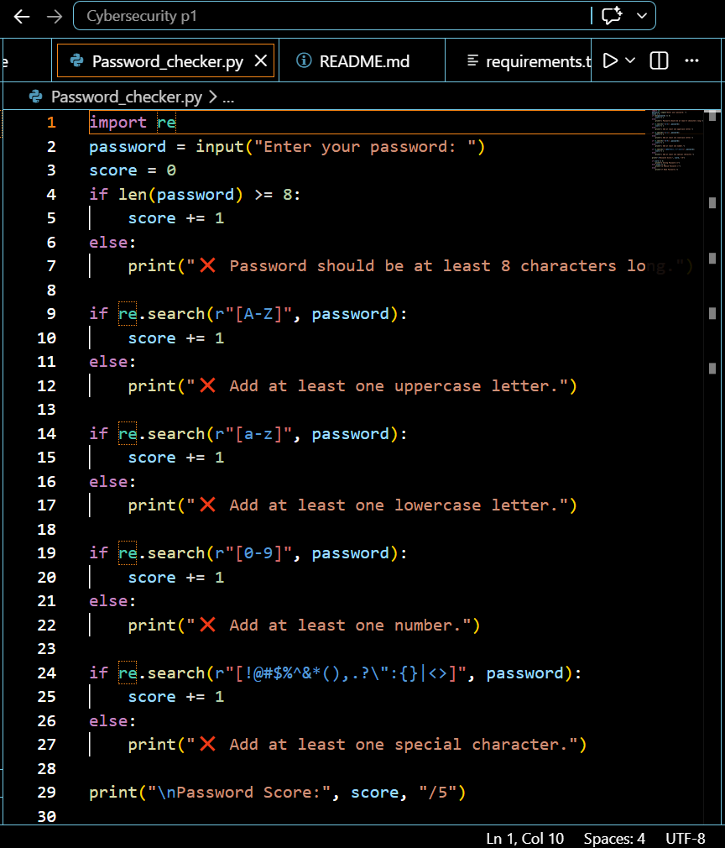

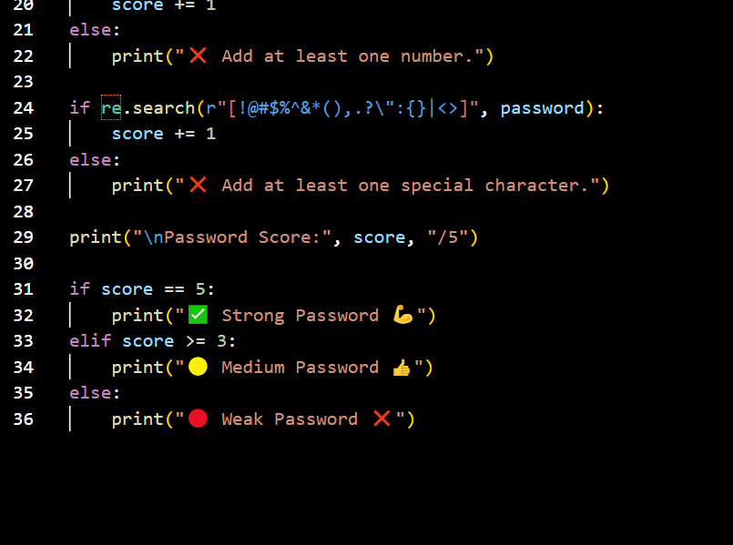
OUTPUT –
abc – Weak password
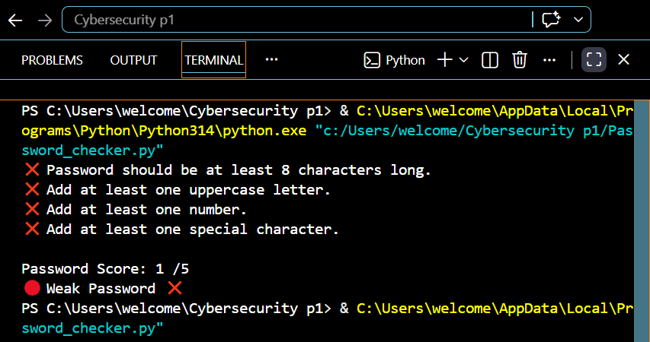
abc12345 - Medium Password
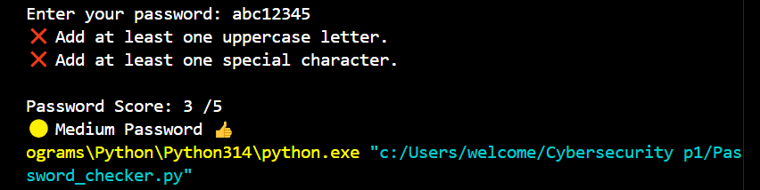
Abc@1234 – Strong Password
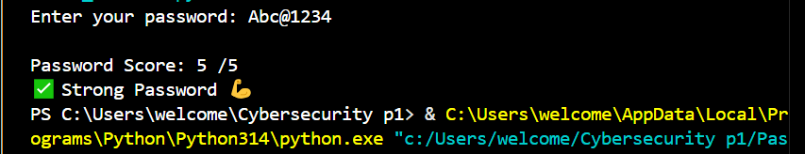

Advantages
Improves password security.
Easy to use.
Provides instant feedback.

Limitations
Basic rule-based checking only.
Does not check leaked passwords.

Future Scope
Add password generator, GUI, entropy calculation and breached-password database checking.

Conclusion
The project successfully analyzes password strength and encourages users to create stronger and more secure passwords.

